QUICK SORT
SOURCE CODE:
#include <stdio.h>
#include <time.h>
void Exch(int *p, int *q)
{
int temp = *p; *p = *q; *q = temp;
}
void QuickSort(int a[], int low, int high)
{
int i, j, key, k;
if(low>=high)
return;
key=low;
i=low+1;
j=high;
while(i<=j)
{
while ( a[i] <= a[key] )
i=i+1;
while ( a[j] > a[key] )
j=j -1;
if(i<j)
Exch(&a[i], &a[j]);
}
Exch(&a[j], &a[key]);
QuickSort(a, low, j-1);
QuickSort(a, j+1, high);
}
int rand();
int main()
{
int n, a[1000],k,clock_tst,et,st,CLOCK_PER_SEC;
double ts;
printf("\n Enter How many Numbers: ");
scanf("%d", &n);
printf("\nThe Random Numbers are:\n");
for(k=1; k<=n; k++)
{
a[k]=rand();
printf("%d\t",a[k]);
}
st=clock();
QuickSort(a, 1, n);
et=clock();
ts=(double)(et-st)/CLOCK_PER_SEC;
printf("\nSorted Numbers are: \n ");
for(k=1; k<=n; k++)
printf("%d\t", a[k]);
printf("\nThe time taken is %e",ts);
}

1.6 INPUT/ OUTPUT

- MERGE SORT
SOURCE CODE:
#include <stdio.h>
#include<time.h>
int b[50000];
void Merge(int a[], int low, int mid, int high)
{
int i, j, k;
i=low; j=mid+1; k=low;
while ( i<=mid && j<=high )
{
if( a[i] <= a[j] )
b[k++] = a[i++] ;
else
b[k++] = a[j++] ;
}
while (i<=mid)
b[k++] = a[i++] ;
while (j<=high)
b[k++] = a[j++] ;
for(k=low; k<=high; k++)
a[k] = b[k];
}
void MergeSort(int a[], int low, int high)
{
int mid;
if(low >= high)
return;
mid = (low+high)/2 ;
MergeSort(a, low, mid);
MergeSort(a, mid+1, high);
Merge(a, low, mid, high);
}
int main()
{
int n, a[50000],k,clock_tst,et,st;
double ts;
printf("\n Enter How many Numbers:");
scanf("%d", &n);
printf("\nThe Random Numbers are:\n");
for(k=1; k<=n; k++)
{
a[k]=rand();
printf("%d\t", a[k]);
}
st=clock();
MergeSort(a, 1, n);
et=clock();
ts=(double)(et-st)/CLOCKS_PER_SEC;
printf("\n Sorted Numbers are : \n ");
for(k=1; k<=n; k++)
printf("%d\t", a[k]);
printf("\nThe time taken is %e",ts);
}
INPUT/ OUTPUT :

USING PRISM’S AND KRUSKAL’S ALGORITHM
MINIMUM COST SPANNING TREE
SOURCE CODE.
#include<stdio.h>
int a,b,u,v,n,i,j,ne=1;
int visited[10]={0},min,mincost=0,cost[10][10];
main()
{
printf("\n Enter the number of nodes:");
scanf("%d",&n);
printf("\n Enter the adjacency matrix:\n");
for(i=1;i<=n;i++)
for(j=1;j<=n;j++) {
scanf("%d",&cost[i][j]);
if(cost[i][j]==0)
cost[i][j]=999;
}
visited[1]=1;
printf("\n");
while(ne<n) {
for(i=1,min=999;i<=n;i++)
for(j=1;j<=n;j++)
if(cost[i][j]<min)
if(visited[i]!=0) {
min=cost[i][j];
a=u=i; b=v=j;
}
if(visited[u]==0 || visited[v]==0) {
printf("\n Edge %d:(%d %d) cost:%d",ne++,a,b,min); mincost+=min;
visited[b]=1;
}
cost[a][b]=cost[b][a]=999;
}
printf("\n Minimun cost=%d",mincost);
} INPUT/ OUTPUT:

MINIMUM COST SPANNING TREE
SOURCE CODE:
#include<stdio.h>
#include<stdlib.h>
int i,j,k,a,b,u,v,n,ne=1;
int min,mincost=0,cost[9][9],parent[9];
int find(int);
int uni(int,int);
main()
{
printf("\n Implementation of Kruskal's algorithm\n\n");
printf("\nEnter the no. of vertices\n");
scanf("%d",&n);
printf("\nEnter the cost adjacency matrix\n");
for(i=1;i<=n;i++) {
for(j=1;j<=n;j++) {
scanf("%d",&cost[i][j]);
if(cost[i][j]==0)
cost[i][j]=999;
}
}
printf("\nThe edges of Minimum Cost Spanning Tree are\n\n");
while(ne<n) {
for(i=1,min=999;i<=n;i++) {
for(j=1;j<=n;j++) {
if(cost[i][j]<min) {
min=cost[i][j];
a=u=i;
b=v=j;
}
}
}
u=find(u);
v=find(v);
if(uni(u,v)) {
printf("\n%d edge (%d,%d) =%d\n",ne++,a,b,min);
mincost +=min;
}
cost[a][b]=cost[b][a]=999;
}
printf("\n\tMinimum cost = %d\n",mincost);
}
int find(int i) {
while(parent[i])
i=parent[i];
return i;
}
int uni(int i,int j) {
if(i!=j) {
parent[j]=i;
return 1;
}
return 0;
}
INPUT/ OUTPUT

KNAPSACK PROBLEM SOURCE CODE:
Using Greedy Method:
# include<stdio.h>
void knapsack(int n, float weight[], float profit[], float capacity) {
float x[20], tp = 0;
int i, j, u;
u = capacity;

for (i = 0; i < n; i++)
x[i] = 0.0;

for (i = 0; i < n; i++) {
if (weight[i] > u)
break;
else {
x[i] = 1.0;
tp = tp + profit[i];
u = u - weight[i];
}
}
if (i < n)
x[i] = u / weight[i];

tp = tp + (x[i] * profit[i]);

printf("\nThe result vector is:- ");
for (i = 0; i < n; i++)
printf("%f\t", x[i]);

printf("\nMaximum profit is:- %f", tp);
}
int main() {
float weight[20], profit[20], capacity;
int num, i, j;
float ratio[20], temp;
printf("\nEnter the no. of objects:- ");
scanf("%d", &num);

printf("\nEnter the wts and profits of each object:- ");
for (i = 0; i < num; i++) {
scanf("%f %f", &weight[i], &profit[i]);
}
printf("\nEnter the capacityacity of knapsack:- ");
scanf("%f", &capacity);

for (i = 0; i < num; i++) {
ratio[i] = profit[i] / weight[i];
}
for (i = 0; i < num; i++) {
for (j = i + 1; j < num; j++) {
if (ratio[i] < ratio[j]) {
temp = ratio[j];
ratio[j] = ratio[i];
ratio[i] = temp;
temp = weight[j];
weight[j] = weight[i];
weight[i] = temp;
temp = profit[j];
profit[j] = profit[i];
profit[i] = temp;
}
}
}
knapsack(num, weight, profit, capacity);
return(0);
}
Using Dynamic Programming:
#include<stdio.h>
int w[10],p[10],v[10][10],n,i,j,cap,x[10]={0};
int max(int i,int j) {
return ((i>j)?i:j);
}
int knap(int i,int j) {
int value;
if(v[i][j]<0) {
if(j<w[i])
value=knap(i-1,j);
else
value=max(knap(i-1,j),p[i]+knap(i-1,j-w[i]));
v[i][j]=value;
}
return(v[i][j]);
}
int main() {
int profit,count=0;
printf("\nEnter the number of objects ");
scanf("%d",&n);
printf("Enter the profit and weights of the elements \n ");
for(i=1;i<=n;i++) {
printf("\nEnter profit and weight For object no %d :",i);
scanf("%d%d",&p[i],&w[i]);
}
printf("\nEnter the capacity ");
scanf("%d",&cap);
for(i=0;i<=n;i++)
for(j=0;j<=cap;j++)
if((i==0)||(j==0))
v[i][j]=0;
else
v[i][j]=-1;
profit=knap(n,cap);
i=n; j=cap;
while(j!=0&&i!=0) {
if(v[i][j]!=v[i-1][j]) {
x[i]=1;
j=j-w[i]; i--;
}
else
i--;
}
printf("object included are \n ");
printf("Sl.no\tweight\tprofit\n");
for(i=1;i<=n;i++)
if(x[i])
printf("%d\t%d\t%d\n",++count,w[i],p[i]);
printf("Total profit = %d\n",profit);
}
INPUT/ OUTPUT

MATRIX CHAIN MULTIPLICATION
SOURCE CODE:
#include <stdio.h>
#include<limits.h>
#define INFY 999999999
long int m[20][20];
int s[20][20];
int p[20],i,j,n;
void print_optimal(int i,int j)
{
if (i == j)
printf(" A%d ",i);
else
{
printf("( ");
print_optimal(i, s[i][j]);
print_optimal(s[i][j] + 1, j);
printf(" )");
}
}
void matmultiply(void)
{
long int q;
int k;
for(i=n;i>0;i--)
{
for(j=i;j<=n;j++)
{
if(i==j)
m[i][j]=0;
else
{
for(k=i;k<j;k++)
{
q=m[i][k]+m[k+1][j]+p[i-1]*p[k]*p[j];
if(q<m[i][j])
{
m[i][j]=q;
s[i][j]=k;
}
}
}
}
}
}
int MatrixChainOrder(int p[], int i, int j)
{
if(i == j)
return 0;
int k;
int min = INT_MAX;
int count;
for (k = i; k <j; k++)
{
count = MatrixChainOrder(p, i, k) +
MatrixChainOrder(p, k+1, j) +
p[i-1]*p[k]*p[j];

if (count < min)
min = count;
}
return min;
}
main()
{
int k;
printf("Enter the no. of elements: ");
scanf("%d",&n);
for(i=1;i<=n;i++)
for(j=i+1;j<=n;j++)
{
m[i][i]=0;
m[i][j]=INFY;
s[i][j]=0;
}
printf("\nEnter the dimensions: \n");
for(k=0;k<=n;k++)
{
printf("P%d: ",k);
scanf("%d",&p[k]);
}
matmultiply();
printf("\nCost Matrix M:\n");
for(i=1;i<=n;i++)
for(j=i;j<=n;j++)
printf("m[%d][%d]: %ld\n",i,j,m[i][j]);
i=1,j=n;
printf("\nMultiplication Sequence : ");
print_optimal(i,j);
printf("\nMinimum number of multiplications is : %d ",
MatrixChainOrder(p, 1, n));
}
INPUT/ OUTPUT
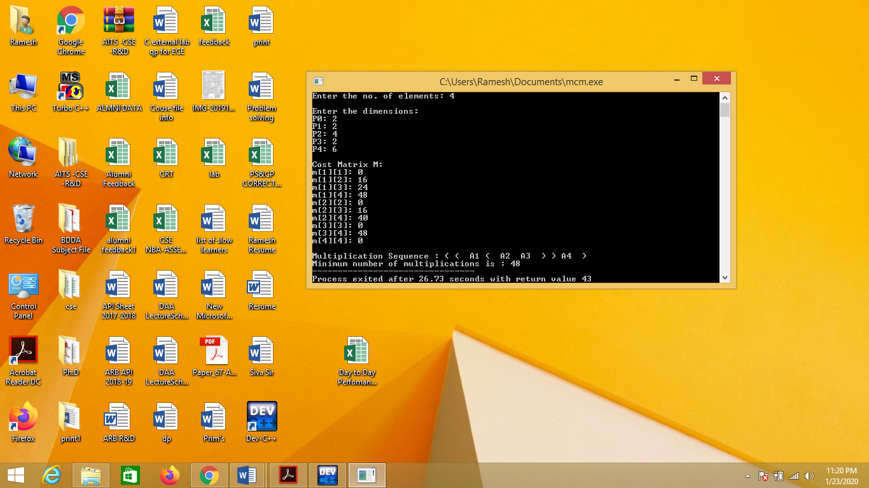

ALL PAIRS SHORTEST PATH PROBLEM

SOURCE CODE.
#include<stdio.h>
int min(int,int);
void floyds(int p[10][10],int n){
int i,j,k;
for(k=1;k<=n;k++)
for(i=1;i<=n;i++)
for(j=1;j<=n;j++)
if(i==j)
p[i][j]=0;
else
p[i][j]=min(p[i][j],p[i][k]+p[k][j]);
}
int min(int a,int b){
if(a<b)
return(a);
else
return(b);
}
int main(){
int p[10][10],w,n,e,u,v,i,j;
printf("\n Enter the number of vertices:");
scanf("%d",&n);
printf("\n Enter the number of edges:\n");
scanf("%d",&e);
for(i=1;i<=n;i++){
for(j=1;j<=n;j++)
p[i][j]=999;
}
for(i=1;i<=e;i++){
printf("\n Enter the end vertices of edge%d with its weight \n",i);
scanf("%d%d%d",&u,&v,&w);
p[u][v]=w;
}
printf("\n Matrix of input data:\n");
for(i=1;i<=n;i++) {
for(j=1;j<=n;j++)
printf("%d \t",p[i][j]);
printf("\n");
}
floyds(p,n);
printf("\n Transitive closure:\n");
for(i=1;i<=n;i++){
for(j=1;j<=n;j++)
printf("%d \t",p[i][j]);
printf("\n");
}
printf("\n The shortest paths are:\n");
for(i=1;i<=n;i++)
for(j=1;j<=n;j++){
if(i!=j)
printf("\n <%d,%d>=%d",i,j,p[i][j]);
}
} INPUT AND OUTPUT:
N QUEENS PROBLEM
SOURCE CODE:
#include<stdio.h>
#include<math.h>
int a[30],count=0;
int place(int pos){
int i;
for(i=1;i<pos;i++){
if((a[i]==a[pos])||((abs(a[i]-a[pos])==abs(i-pos))))
return 0;
}
return 1;
}
void print_sol(int n){
int i,j; count++;
printf("\n\nSolution #%d:\n",count);
for(i=1;i<=n;i++){
for(j=1;j<=n;j++){
if(a[i]==j)
printf("Q\t");
else
printf("*\t");
}
printf("\n");
}
}
void queen(int n){
int k=1;
a[k]=0;
while(k!=0){
a[k]=a[k]+1;
while((a[k]<=n)&&!place(k))
a[k]++;
if(a[k]<=n){
if(k==n)
print_sol(n);
else{
k++;
a[k]=0;
}
}
else
k--;
}
}
main(){
int i,n;
printf("Enter the number of Queens\n");
scanf("%d",&n);
queen(n);
printf("\nTotal solutions=%d",count);
}
INPUT/ OUTPUT

